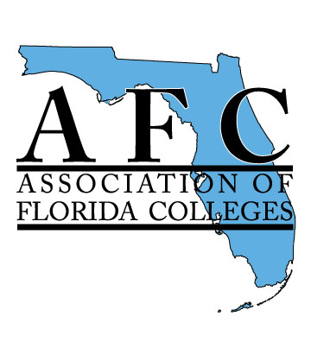
Learning Resources Commission
Executive Committee Phone Conference
March 24, 2015
Minutes

Began at 11:30 a.m.
In attendance: Isabel Hernandez, Chair (MDC)
Kendra Auberry, Vice Chair (IRSC)
Lena Phelps, Secretary/Treasurer (SFSC)
Not in attendance: Grenka Bajramoski Fletcher, Webmaster (VC)
- Exemplary Practice application and deadlines

Kendra added information to the application about bonus points, which can be earned by presenting at the joint commission super conference, any other commission conference, any of the region conferences, or an online presentation. It was agreed that a submission could earn up to 20 bonus points—5 points for each presentation. (After the meeting, it was decided not to include the fall conference as it was not feasible with the deadline).

Deadline – April 30th electronically to Isabel who is setting up the judging panel.

Isabel will compose an email so Lena can send it out today with the application.

- Joint Commission invite
The Joint Commission Super Conference is still looking for proposals. The deadline is April 3rd. Sponsors are also needed. Isabel will compose an email for Lena to send out reminding commission members to register, submit proposals, and assist in finding sponsors. Marsha Kiner sent a letter that can be used for sponsors.
- Region V – Roadshow

Robert Flores would like to have each commission represented at each region conference. Tables will be set up and available. Isabel will compose an email for Lena to send out to all Learning Resources Commission members asking for volunteers to sit at the table or at least put out information about the commission. She nor Kendra nor Lena will be able to attend their respective region conferences. The region conferences are as follows:
Region I – 4/24 @ TBA
Region II – 4/24 @ SJRSC, St. Augustine
Region III – 6/11 @CCF, Ocala
Region IV – 4/17 @ FSWSC, Ft. Myers
Region V – 3/27 @ PBSC, Palm Beach Gardens
Adjourned at 12:05 p.m.

