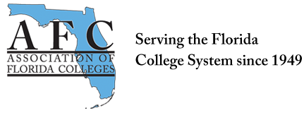
ADMINISTRATION COMMISSION MEETING
May 8, 2019
3:00 p.m.
In attendance: Brenda Rante, Kerri Hughes, Lynn O’Dell, Jackie Edwards, Tracey Glidden, Lisa Lopez, Nicole Duslak. Mark Thompson joined at 3:08.
Meeting called to order at 3:04pm.
- Teaching and Learning Conference April 3 – 5, 2019
- Leadership presentation – we had 12 people attend
- Panel Discussion – three panelist and 18 people attended, we received good feedback on the panel.
- Fundraiser – we raised $41.00

- Action Items
- Review the current Bylaws – may need to make an addition
  - We changed bylaws last year so chairs only serve a one-year term. We are looking to get a new chair for next year, but we may need to adjust bylaws accordingly. Election procedures in Commissions section of Standing Rules indicate that two year terms are permissible.
- Update information on the AFC Website. Updating to Facebook to come soon via Mark.
- Discuss marketing strategies – Survey Questions- options for sending it out are discussed. For example, networking, mentoring, and PD. Option for linking it to our website is discussed. Any thoughts about questions on the survey should be e-mailed for consideration.

- Board of Directors meeting Monday, May 13
Lynn will send update after the meeting.
- Administration Commission Board Meetings Conference Calls
- Sometime in July
Meeting adjourned at 3:26
Submitted by:
Nicole Duslak
Secretary
Administration Commission

