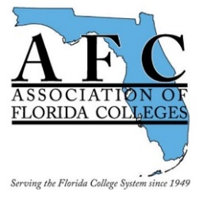

Facilities Commission

2019 Spring Conference

In Partnership with School Dude and Belfor

May 16—17, 2019

7:30 a.m.—4:30 p.m.





May 16 Agenda

**7:30 - 8:00 Registration -** Continental breakfast

**8:00 - 8:30 Welcome**

School Dude Workshops

**8:30 - 9:30 “*Morning Inspiration Session”*** Josh Peach – Dude Solutions

**9:30 - 9:45 Break**

**9:45 - 10:45 *“Modern Technology & Its Impact on Campus M&O”*** – Dude Solutions

**10:45 - 11:00 Break**

**11:00 - 12:00 “*Complete Guide to Event Management in Higher Ed.”*** – Dude Solutions

**12:00 - 1:15 Lunch- Peer Networking** (RSVP limited seating)

**Session A:**

**1:15 - 2:15 “*Bridging the Gap + Leaving a Legacy”*** – Dude Solutions

**2:15 - 2:30 Afternoon break**

**2:30 - 3:30 “*Finance’s Critical Questions for Facilities*”** – Dude Solutions

**3:30 - 4:30** Closing Q&A, Round table discussion & one-on-one

Facilities Commission Workshops

**Session B:**

**1:15 - 2:15 “*School Dude - Click 2 Buy”*-** Presenter – Joseph Thompson-Wilda, Grainger

**2:15 - 2:30 Afternoon break**

**2:30 - 3:30 “*Access Controls & Mass Notification”*** Affordable Options, SFSC Bid results. Go Ramnarain, Robert Flores, Cheryl Arpasi

**3:30 - 4:30 *“Contingencies for Incident Recovery”*** (What is the plan after an incident?) Belfor Property Restoration - Presenters -Larry Somerville & Jason McGlinchey

**6:00 – 8:00 *Facilities Business Meeting/Dinner & DJ*** (Dinner on your own)

****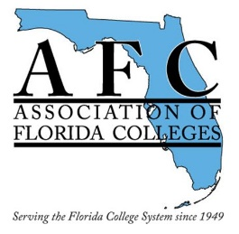Facilities Commission

2019 Spring Conference

In Partnership with School Dude and Belfor

May 16—17, 2019

7:30 a.m.—4:30 p.m.

May 17 Agenda

**7:30-8:00 Registration –** Continental Breakfast

**8:00-8:15 Welcome**

**8:15-8:45 Opening Session**

**“*What to Anticipate for Hurricane Season 2019”***

Guest Speaker - LaTosha Reiss, Emergency Manager,

Highlands County EOC

**8:45 - 10:45 *“Hurricane Irma – Best Practices”***

Guest Speaker - Dr. Jonathan Gueverra, President,

Florida Keys Community College

**10:45 -11:00 Break**

**11:00 - 12:00 *“Hurricane Michael - Best Practices”***

Guest Speakers – James C. McDougall, Director,

Facilities Management; David A. Thomasee, Director,

Campus Safety, Gulf Coast State College

**12:15 -1:15 Lunch**

**1:30 - 2:30 “*Red Alert Program*”**– Tabletop Discussion

Presenters- Larry Somerville, Jason McGlinchey - Belfor

**2:30 - 2:45 Break**

**2:45 – 3:15 “*Prepare, Respond, Recover” -*** Hurricane Emergency Checklist

Presenter **-** Joe Thompson-Wilda, Gov. Acct. Relationship Manager, Grainger

**3:15 - 4:30 *“Plan for Action”*** – Round TablePanel- Joshua Davis, FCSRMC

CONNECTING the DOTS with FACILITIES