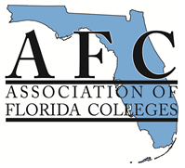
AFC LEARNING RESOURCES COMMISSION
Virtual Conference Call for Proposals
The Learning Resources Commission seeks short presentations for our Virtual Conference on Friday, March 1, 2018. Presentations should be relevant to the members of Learning Resources, including librarians, administration, faculty, staff, and tutors in libraries, learning resource centers, and learning support units.

The LRC Virtual Conference is a free conference that draws a wide variety of attendees from across the Florida College System.

Presentations will be about 20 minutes long with an additional 5 minutes for questions and answers.

Please send your proposal of no more than 500 words electronically no later than Friday, February 15th, 2019 by email to the Chair of the Learning Resources Commission, Claire A. Miller at millerc@southflorida.edu. I’m also happy to answer any questions you might have. I look forward to receiving your nominations.

Sincerely,

Claire A. Miller

Chair, Learning Resources Commission

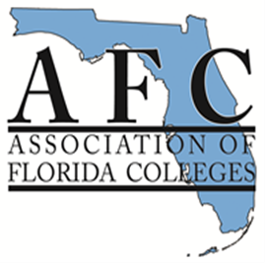
LEARNING RESOURCES COMMISSION
2019 EXEMPLARY PRACTICE AWARDS
Nomination Form
Complete and submit this form with your nomination.
Nominations must be submitted electronically to the Learning Resources Commission Chair by February 15, 2019.

Check one category:
___Library: MLS librarians, faculty, or paraprofessionals who work in a library
___Learning Support Services: Faculty, administrators, tutors, or paraprofessional staff who work in a tutoring center, student support center, or other related unit.
Title of Nominee's Program:_____________________________________________________
Nominee’s Name:______________________________________________________________
Nominee's College:_______________________________Campus:______________________
Nominee’s E-Mail:_____________________________________________________________
Are you able to present at the Virtual Conference on March 1st? _____________________
Are you able to present at annual conference on November 6-8? ______________________
Reason for nomination: Attach a brief summary (not to exceed 1,000 words) about the program, including information that supports the criteria listed on the judging criteria page. Include any supporting documentation.
Deadline Date: Friday, February 15, 2019
Submit nomination form, brief summary and supporting documentation electronically by email to Claire A. Miller, LRC chair at millerc@southflorida.edu

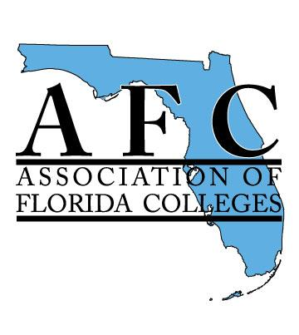
Association of Florida Colleges
Learning Resources Commission
Exemplary Practice Awards
Judging Criteria and Scoring Rubric
_____Library/Learning Resources Center Services
_____Learning Support Services
PURPOSE
The purpose of this award is to recognize exemplary practices in libraries and learning resources centers as well as learning support service centers within the colleges of the Florida College System. The award also serves to increase awareness of the role that libraries, learning resources centers, and learning support service centers play in student learning & success and in fulfilling the mission of Florida’s colleges.
Title of Nominee's Practice:____________________________________________________________
Nominee’s Total Points:_______________________________________________________________
CRITERIA DESCRIPTION | Points | Earned Points
PURPOSE | (50)
Degree that practice supports the mission of Florida College System and the Association of Florida Colleges | 10
Degree that practice supports student learning | 20
Degree that the practice has a marketing, public relations or advocacy outcome | 20
EXEMPLARY CRITERIA | (50)
Adaptability of idea – Can others easily adopt and adapt the practice? | 5
Illustrative quality of support materials – How well do the support materials demonstrate or explain the practice? | 5
Accountability/assessment of practice – Is there evidence that the practice is measurably making a difference? | 20
Innovation or originality of idea | 10
Recommendations by student(s), colleague(s) or faculty included that confirms or verifies that practice makes a difference/meets criteria (emails, notes, or formal letters) | 10
TOTAL POINTS | 100

