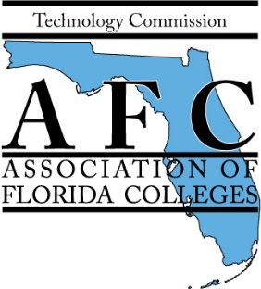

Call for Presentation Proposals
for
Joint Region I & Technology Commission
2020 Conference Theme: “Technology Trends, Challenges, & Opportunities”
on April 24, 2020
at Northwest Florida State College

Our Region I: Chipola College, Gulf Coast State College, Northwest Florida State College, Pensacola State College, and Tallahassee Community College cordially invite you to submit a presentation proposal for the annual Joint Region I & Technology Commission 2020 Conference. The AFC Joint Region I & Technology Commission 2020 Conference seeks proposals for presentations that focus on the conference’s theme " Technology Trends, Challenges, & Opportunities” and any workshop that aligns with the goals and objectives of AFC. Presentations can be related to technology, curriculum, administration, employee benefits, self-care, student development, recruitment and retention.

On this day, more than 100 administrators, faculty and staff members from our Florida College System will attend this conference. Our members are from diverse professional backgrounds, representing all college areas such as faculty, administration, finance, public relations, technology, maintenance, athletics, professional development, institutional research, and student development.
All submissions will be evaluated by the Joint Region I & Technology Commission 2020 Conference Planning Committee. Deadline for submission of abstracts will be February 14, 2020. You will be notified of the review committee’s decision by February 24, 2020.

Send proposals with the words “Proposal for Joint Region I & Technology Commission 2020 Conference” in the subject heading to: Jessie Clayton of Tallahassee Community College at claytonj@tcc.fl.edu.

Submission due by February 14, 2020

Name of presenter(s) and Job Title(s):

Contact Information:

Abstract of presentation (150 words or less):

Bio of Presenter(s) (100 words or less):

Technology needs (laptop, audiovisual equipment, etc.):

