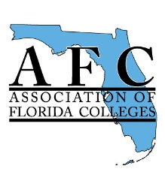
AFC RETIREES:
WE NEED YOU TO BECOME MENTORS

If you are retired or planning to retire and would like to be a “Go to” person and share your expertise as a retiree mentor with your fellow colleagues, please provide your contact information:

Name: _______________________________

Address: ______________________________________________________
______________________________________________________________

Institution: ____________________________________________________

Phone (other than college #)______________________________________

Email (other than College) ______________________________________

Areas of your expertise: (Mark all that apply)

Administrative
Adult and Continuing Education
Career and Professional Employees
Communication and Marketing
Equity
Facilities
Faculty
Health Care
Institutional Effectiveness
Instructional Innovation
Learning Resources
Occupational and Workforce Education
Student Development
Technology
Trustee

Please return completed form to: Barbara Cohen at barbaracohen213@gmail.com.

