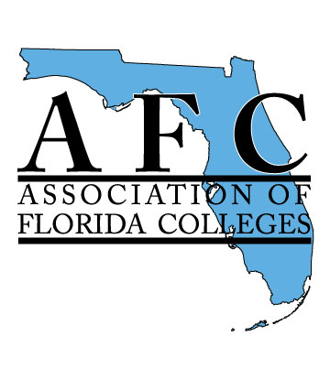
MEMBERSHIP INCENTIVE PLAN AGREEMENT

I authorize the Payroll Department of _____________________ College to deduct the current (and subsequent) approved rate of AFC dues as set by the Association of Florida Colleges from my salary beginning July 1, 2020 until further notice in accordance with the college’s payroll deduction plan.
I understand that my AFC Membership will be continuous on a year-to-year basis.
_____________________________
Signature
_____________________________
Printed Name
_____________________________
Employee ID No.

