Association of Florida Colleges (AFC)
Region III Report

Central Florida Chapters
May 1, 2019 - August 30, 2019

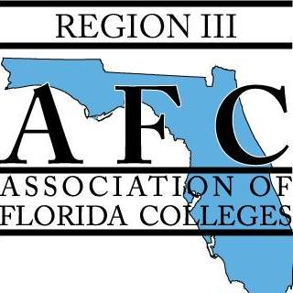

Region Director Kim Sellers
College of Central Florida

Director Elect Charlene Latimer
Daytona State College

Region Activities:

This summer, Region III has taken the AFC Value of Community to heart by giving of time to assist in two service projects. During the month of June, Region III members traveled to Eastern Florida State College to assist with Summit of the Seven Boys and Men Educational Conference. The conference, which began on Friday, June 7th, provides life-changing educational experiences for the youth and young men throughout the community. Our AFC members provided assistance through various activities both Friday evening and Saturday, such as presenting at one of the workshops, setting up for the luncheon, serving lunch and of course serving cake. Each of our members was touched by the positive influence the conference had on the youth and young men in attendance. Region III would love to continue volunteering at this conference in the future.
July brought about some fun in the sun as Region III members gathered in Ormond Beach for a beach cleanup with Danielle Ramsey from the Volusia County Environmental Management. Members spent the morning of July 27th learning about the negative effects our trash has on the animals within this ecosystem. Danielle shared her in-depth knowledge of the different species of sea turtles who consider the Volusia County beaches their nesting grounds. The efforts of the Region III members resulted in the collection of approximately 10 pounds of trash from the Ormond Beach Area. This activity made us more conscious of the items we bring with us to the beach.
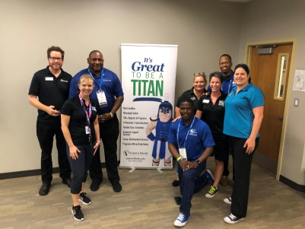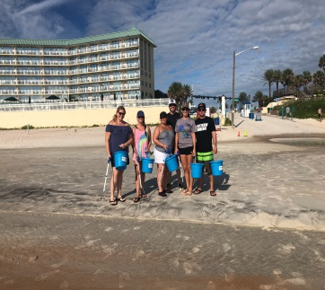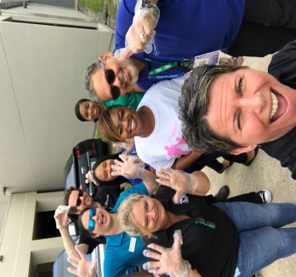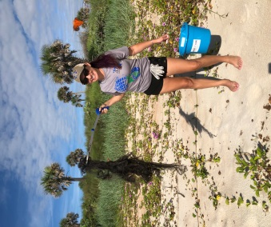

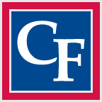
College of Central Florida
Submitted by Ron Kielty– Chapter President

2019/2020 Chapter E-Board Officers
President: Ron Kielty President-Elect: Victoria Colleli Vice President: Cynthia Moody Secretary: Tina Banner Treasurer: Cara Bennett Immediate Past President: Sharon Altany Citrus Campus Representative: Alicia Harrison Levy Campus Representative: Krystle Skelly Activities Chair: Amanda Camp Fundraising Chair: Jean Scheppers Legislative Representative: Jessica Kummerle Membership Chair: Norma Walcott Publicity Chair: Deyanira Garcia Historian: Rory Wells

- College Park Elementary School donation for school supplies. Tuesday August 6th Chapter presented two $500 checks to the school for student school supplies.

- The First Chapter meeting after the summer break was held on Aug 20. The meeting had three long time members from different areas of the college tell their story of why they joined AFC and why they continue to support AFC and the college system.

- Starting Sept. 17, a long-term fundraising activity will begin with the insider auction. Funds generated will be used to fund community service and AFC activity’s

- CF coming to serve thanksgiving dinner the Tuesday (Nov. 26) before Thanksgiving at the Salvation Army Evangeline Booth Gardens apartments.

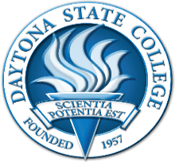
Daytona State College
Submitted by Max Swanton – Chapter President

May –
Chapter donated memorial brick in honor of AFC member and Nursing staff, Linda Vought

June -
7th and 14th - Staff Education Days - 'The Benefits of Membership' presentation

July -
29th- Beach cleanup - Ormond Beach - Danielle Ramsey from Volusia County Environmental Management

August –
Membership Drive - table presentation at Welcome Back event
“Thank You” Popcorn delivered to all AFC members
Fall planning presentation 'What is AFC?'

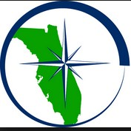
Eastern Florida State College
Submitted by Donna Hamilton- Chapter President

Conference & Commission Participation:

Six members attended the Region III Meeting April 12, 2019

Seven members attended the Student Development Conference May 14, 2019 to May 17, 2019

One attended the Membership Development Workshop July 10, 2019

Two attended Campus Safety Symposium July 11 & 12, 2019

Breakfast or Lunch and Learns Professional Workshops:

AFC 101 how to get engaged on and April 11, 2019

Ashley Olund - Assistant Professor and Librarian Provides a session on Library Services available to staff and faculty. April 19, 2019
Introduction to Mindfulness May 22, 2019

Community Service Project for Endeavor Elementary School Supplies - March 4 to June 27, 2019

Social:

Ice Cream Social June 26, 2019

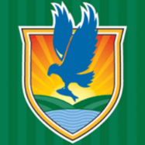
Lake-Sumter State College
Submitted by Joan Thurman – Chapter President

Chapter Administration & Meetings:

• On the 8th of May, 2019, the LSSC Chapter of AFC held our annual membership meeting. AFC President Marjorie McGee was the guest speaker with more than 45 people in attendance. Everyone who attended the meeting was entered into a draw for the Chapter to pay their AFC dues in an amount not-to-exceed $45. New AFC member, Gabrielle Longley won the drawing and her first year’s dues were paid by the Chapter.

• On the 24th of June, 2019, LSSC Chapter of AFC held our annual summer workshop. Due to recent resignations and appointments of new Board members, this was a good time for everyone to get together, take some time to reconnect, and plan for the upcoming year. We put together a planning calendar and we have made commitments for the upcoming year for meetings, fundraisers, recruitment, etc.

The following is the 2019-2020 Executive Board for LSSC Chapter of AFC:

Joan Thurman, President
Cynthia Nash, Past President
Katie Sacco, Vice President
Mary Heikkinen, Historian
Kim Kidd, Membership
Cynthia Christman, Acting Treasurer
Erin North, Public Relations Representative
Vacant, Secretary
Vacant, Leesburg Representative
Vacant, Sumter Representative
Brenda Skoczelas, South Lake Representative

• On October 9th, Joan Thurman and Katie Sacco will be attending the LSSC delegation meeting to discuss current college issues and 2020 budget priorities.

• Several Board members are planning on attending the upcoming annual conference in November. We look forward to seeing everyone there.

Seminole State College of Florida
Submitted by Charity Lo-Giudice – Chapter President

Membership:

Information Table — Members from the Seminole State College AFC Board hosted a chance drawing and membership information table at the Faculty Welcome Back event. (August)

Information Table — Members from the Seminole State College AFC Board hosted a chance drawing and membership information table at the Adjunct Information Fair. (August)

Community Service:

Eyeglasses Donation — Chapter collected items gently used eyeglasses to give the Oviedo Winter Springs Lions Foundation. (May-June)

Chapter Administration & Meetings:

Nominations and Election for new 2019-20 AFC Board (May-June)

Board meeting was held on August 23.

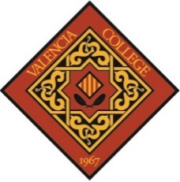

Valencia College

No report at this time

