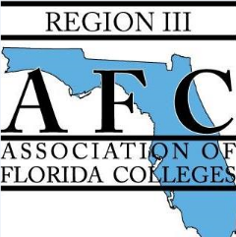



**Region III Spring Conference 2019  
Service Project**

Kimberly’s Center for   
Child Protection

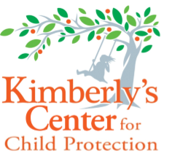Each year Marion County experiences more than 4,000 reports of suspected child abuse and neglect. Kimberly’s Center exists to respond to, protect, and restore these children so they can get the help, hope, and healing they need. The team at Kimberly’s Center provides expert medical evaluations and forensic interviews to assist in the investigation as well as ongoing child advocacy and trauma therapy to help children recover and regain a sense of normalcy. All services at Kimberly’s Center are provided at no cost to the family. Please visit [KimberlysCenter.org](http://kimberlyscenter.org/) to learn more or make a donation.

WISH LIST:

|  |  |
| --- | --- |
| **FOR THE TOY CHEST**  * Hot Wheels, Toy Trucks , Baby Dolls  * Costume Jewelry (for teenagers)  * Footballs, Soccer Balls, Basketballs, Baseballs and Gloves  * Scented Lotions, Body Splash Sets  * Children’s books, Chapter Books (all ages, gently used), and Coloring Books and Crayons | **FOR THERAPY**  * Tempera Paints in bottles  * Construction Paper, Washable Markers, Glue  * Arts and Crafts Foam (seasonal)  * Strathmore Artist Paper (11x14) for Art and Soul Paintings  * Journals and Nice Pens (remember the young men) |
| **FOR CENTER NEEDS**  * Copy Paper  * Office Supply Store Gift Cards  * Grocery Gift Cards  * Walmart Gift Cards  * Gas Gift Cards– To assist families with bringing children  * Children’s DVD’s (New or Used) | **MONETARY CONTRIBUTIONS ARE ALWAYS APPRECIATED**  $75-$100 Therapy Session for Boy or Girl  $200 Good Touch Bad Touch Training Materials for 25 Children  $100 Forensic Interview  $150-$500 Medical Exam for One Child |