**Region III Spring Conference 2019**

**Showcasing presentations from the Career and Professional Employee Commission, Technology Commission, Campus Safety Commission, and Institutional Effectiveness, Planning, and Professional Development Commission**

***MAKING CONNECTIONS: Enhancing Quality, One Connection at a Time!***



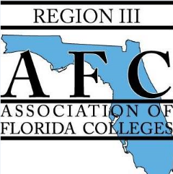

**April 12, 2019**

**Registration Form**

**Please email completed form to** [**sellersk@cf.edu**](mailto:sellersk@cf.edu) **by April 1, 2019**

**Conference Location:**

College of Central Florida

3001 SW College Road

Ocala, FL 34474

Name: _______________________________________________________________________________________

Title: ________________________________________________________________________________________

College: _____________________________________________________________________________________

Presenter No___ If so, name of session? ______________________________________________________

**Registration Cost: $50**

**Please make checks payable to**: College of Central Florida. **In check memo line: AFC** Region III Conference. Cash and check payments will be accepted on day of conference.

**Mail check payments to:**

College of Central Florida

Attention: Kim Sellers

3001 SW College Road

Ocala, FL 34474

**To make lodging reservations, please contact:**[Hilton Ocala](https://www3.hilton.com/en/hotels/florida/hilton-ocala-OCFOHHF/index.html)

3600 Southwest 36th Ave  
Ocala, Florida, 34474  
1-352-854-1400